
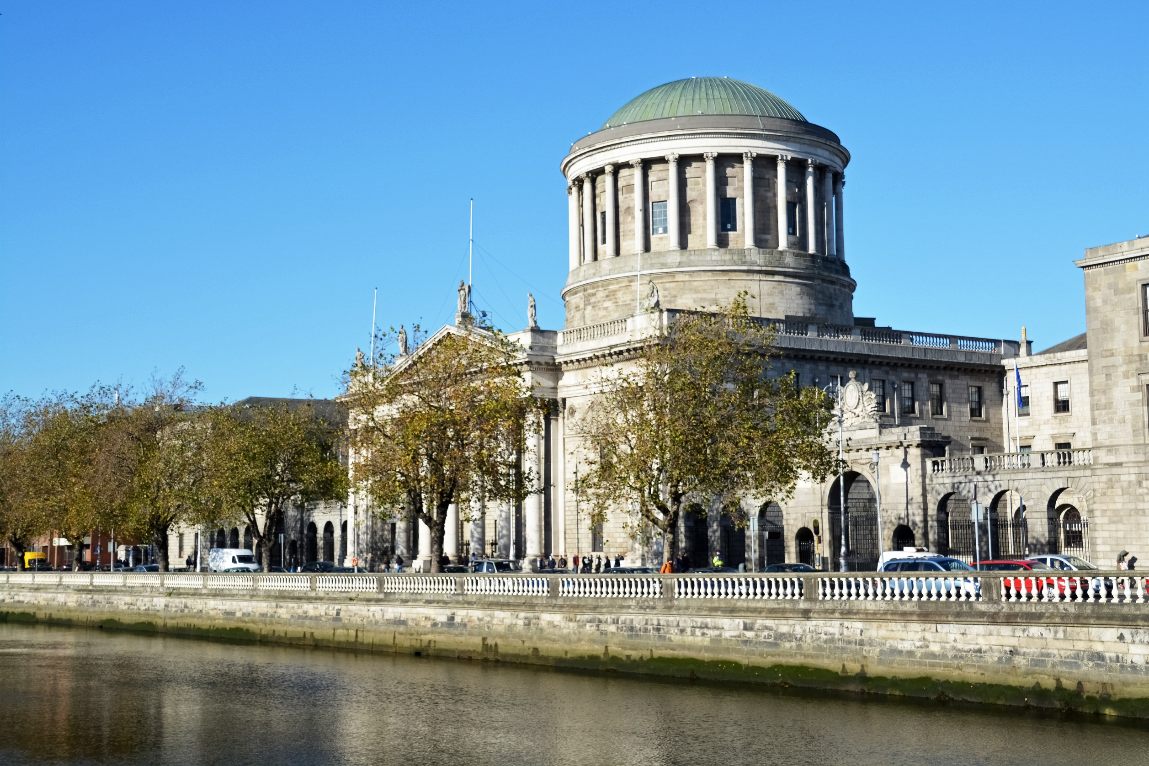

Gender Pay Gap Report
2023

Contents
Courts Service Gender Pay Report 4
1. Introduction 5
2. Courts Service 2022 7
3. Courts Service 2023 8
4. Data 9
5. Staff Profile and Pay Statistics 10
6. Using Gender Pay Gap information 14
7. Supporting Gender Equality 15

What does this information mean for the Courts Service? 12

Introduction

The Courts Service sets out in its People and Organisation Strategy 2022 to 2024, its desire to be a workplace where everyone can thrive; be a place where people want to invest their careers to realise personal and organisation goals. We aspire for the Courts Service to be a place where everyone feels able to come to work as their authentic self.
All public bodies in Ireland have responsibility to promote equality, prevent discrimination and protect the human rights of their employees, customers, service users and everyone affected by their policies and plans.
Delivering on our commitment to be a place where everyone feels equal is demonstrated in part by reporting our gender pay gap and the participation of all genders across all grades.
The Courts Service as a civil service employer has a range of policies to support equal opportunities and female participation in the workforce. These include shorter working year, maternity leave, parental leave, flexi time and paternity leave.
It is important to point out that the gender pay gap is distinct from the concept of unequal pay. Unequal pay means an employee cannot be paid less compared to another employee of the opposite sex who is doing work of equal value.
In 2022 our mean hourly gender pay gap was -2.2% and in 2023 it was -2.4%. Females comprise 60% of the organisation. In effect females earn 2.2% more than males in 2022 and 2.4% more in 2023. Therefore, there is no immediate concern for female participation in the workforce. However, if the trend were to move significantly more in favour of females, this may become an issue as our desire is to reflect the gender make up of society.

The Gender Pay Information Act, 2021
The Gender Pay Gap Information Act was signed into Irish law in 2021 and began having practical effect in 2022 for employers with more than 250 employees.
Under the Act, employers are required to publish information on their gender pay gap – specifically, gender-based differences in mean and median hourly remuneration, mean and median bonus payments and the percentage of employees paid a bonus or benefits in kind.
The Gender Pay Gap Information Act 2021 defines the hourly gender pay gap as the difference between the mean hourly remuneration of male employees and female employees expressed as a percentage of the mean hourly remuneration of male employees.
Each organisation is also obliged to publish a broader explanation, giving the underlying reasons for any gap, and the measures the organisation intends to take to address it. All of this will be public information, published either on the organisation website or made available on a central portal which the government intend to ultimately provide.

Courts Service 2022
The mean hourly gender pay gap was -2.2%.
Females earned on average €0.56 more per hour than their male colleagues.
The median hourly gender pay gap was -12.2%.
When the data is ordered from least to greatest, females earned €2.40 per hour more than males.
The data provided is based on all those who were paid on 23 June 2022 (fortnightly) and on 24 June 2022 for weekly paid staff. Salaries and hours worked reflect the cumulative remuneration and hours worked including overtime for the previous 12 months.

Courts Service 2023
The mean hourly gender pay gap was -2.4%.
Females earned on average €0.65 more per hour than their male colleagues.
The median hourly gender pay gap was -12.2%.
When the data is ordered from least to greatest, females earned €2.5 per hour more than males.
No employee of the Courts Service receives bonus payments or benefits in kind.
The data provided is based on all those who were paid on 22 June 2023 (fortnightly) and on 23 June 2023 for weekly paid staff. Salaries and hours worked reflect the cumulative remuneration and hours worked including overtime for the previous 12 months.

Data
The data used in the analysis is provided by the National Shared Service Office (NSSO). The NSSO calculated the relevant gender pay gap statistics for the Courts Service staff using data from the payroll system and human resources employee information database.
Remuneration includes base salary, higher duties allowance, overtime, sick pay, maternity pay, on call- and call-in compensation, public holiday pay, video link allowance, private secretary allowance, tipstaff and service officer allowances.
  - Staff Profile
The Courts Service has more females than males as shown in the table.

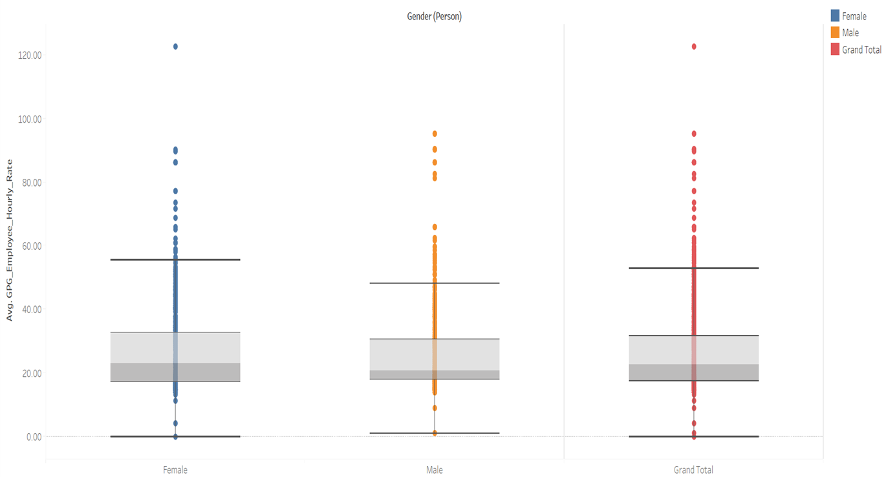
  - Pay Distribution
The table above shows the 2023 distribution of the hourly rate of pay for both genders. The highest earning female earned €122.6 per hour and the highest earning male earned €95.1 per hour.
Similarly for 2022, the highest female hourly rate was €105 per hour and the highest male hourly rate was €89 per hour as shown in the table overleaf.
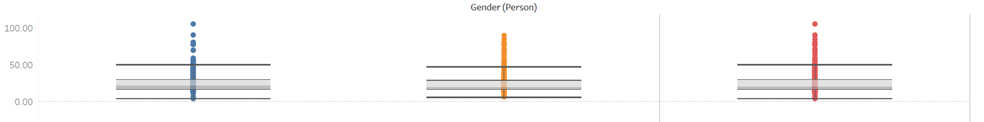

  - The average salary by gender
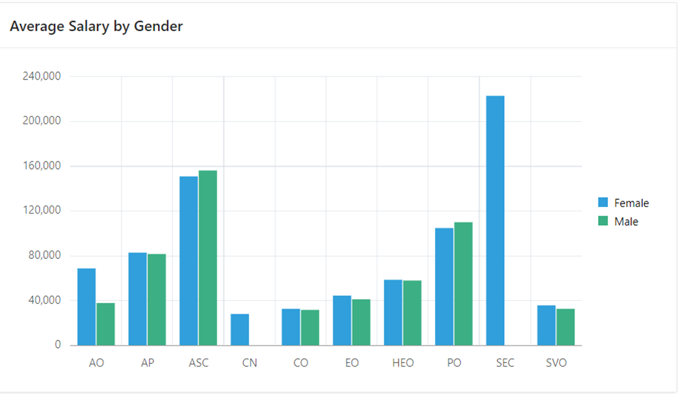
2022

The grades in order of seniority are as follows:
Sec Secretary General or CEO
ASC Asst Secretary & Office Holders (Legal Costs Adjudicators & County Registrars)
PO Principal Officer
AP Assistant Principal Officer
AO Administrative Officer
HEO Higher Executive Officer
EO Executive Officer
CO Clerical Officer
SVO Service Officers, Court Messengers and Tipstaff
CN Cleaner
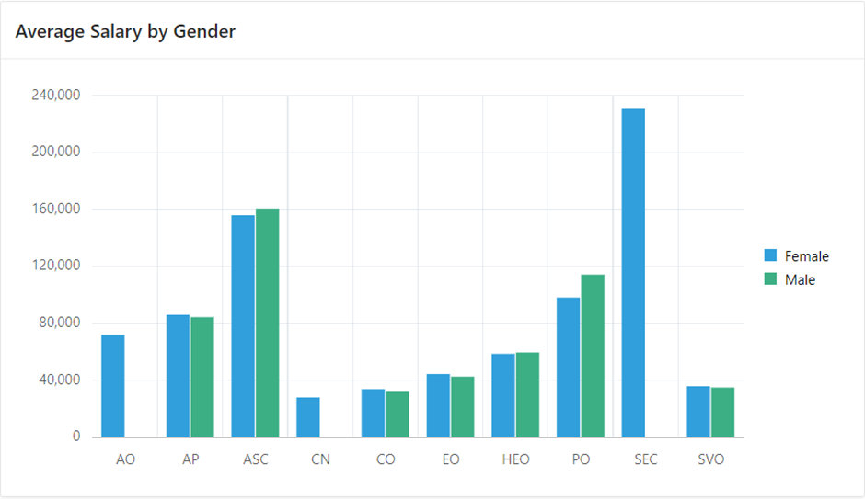
2023

The male hourly rate of pay is higher at the grades of Assistant Secretary and Principal Officer. For the remaining grades the female rate is higher or the same.
  - Age Band Analysis

The significant change these tables show is the impact of the increase of the female hourly rate versus the male hourly rate of pay in the 61 to 70 age bracket in 2023 compared to 2022.
In all other age brackets the difference in the hourly rate of pay is relatively small.

Using Gender Pay Gap information.
The Courts Service established an Inclusion Group under the governance of our People & Organisation Strategy. All public bodies in Ireland have responsibility to promote equality, prevent discrimination and protect the human rights of employees, customers, service users and everyone affected by their policies and plans.
We began by developing a Courts Service Public Sector Duty Action Plan to deliver on our obligations to be equitable and fair, attract and develop a diverse workforce and ensure the Courts Service is a place where everyone feels able to come to work as their authentic self.
The benefit of gender pay gap reporting is to provide data for us to evaluate and challenge ourselves around Equality, Diversity and Inclusion in our workplace and consider ways to enhance our support to all genders.
We look forward to reporting in the years to come and developing our insights and interventions in this area.

