
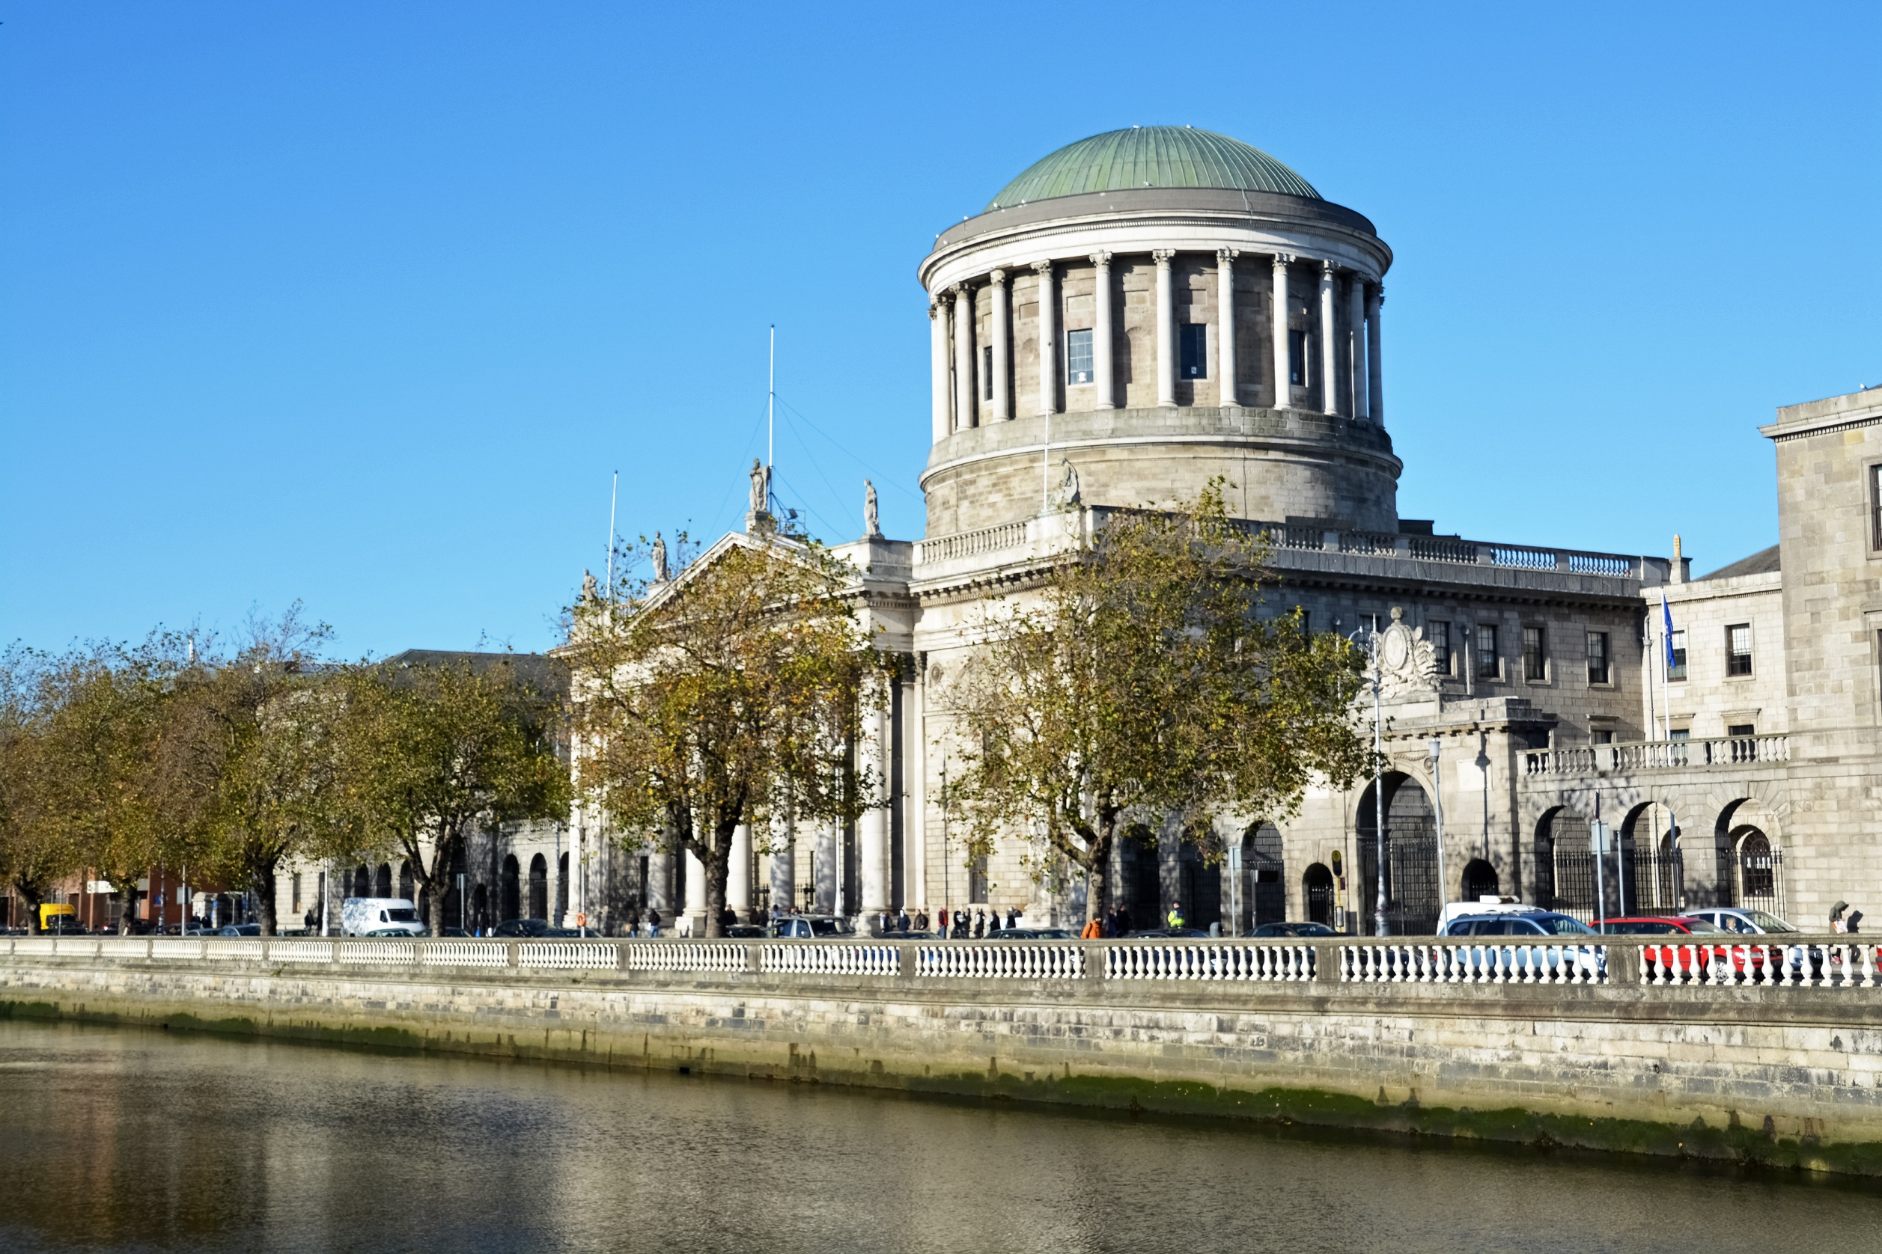

Gender Pay Gap Report
2024

Contents
1. Introduction 3
2. The Gender Pay Information Act, 2021 4
3. Courts Service 2024 5
4. Courts Service 2023 6
5. Courts Service 2022 7
6. Data 8
7. Using Gender Pay Gap information. 12

Introduction

The Courts Service set out in its People and Organisation Strategy 2022 to 2024, its desire to be a workplace where everyone can thrive; be a place where people want to invest their careers to realise personal and organisation goals.
All public bodies in Ireland have responsibility to promote equality, prevent discrimination and protect the human rights of their employees, customers, service users and everyone affected by their policies and plans.
Delivering on our commitment to be a place where everyone feels equal is demonstrated in part by reporting our gender pay gap and the participation of all genders across all grades.
The Courts Service as a civil service employer has a range of policies to support equal opportunities and female participation in the workforce. These include shorter working year, maternity leave, parental leave, flexi time and paternity leave and since June 2024, extends into Menopause support. Policies were introduced in 2024 to support those experiencing Domestic Violence and parents leave was increased for fathers.
Gender pay gap is distinct from the concept of unequal pay. Unequal pay means an employee cannot be paid less compared to another employee of the opposite sex who is doing work of equal value.
For the last three years our average gender pay gap is as follows:
- 2024 our average gender pay gap was -0.05%
- 2023 it was -2.4%; and
- 2022 it was -2.2%.

In effect females in 2024 earned 0.05% on average per hour more than males in 2024. The gap in favour of females has reduced year on year. The Courts Service is bound by civil service pay grades and therefore has no control over deciding pay for employees.

Females comprised 61% of the organisation for the reporting period of this report. It can be concluded there is no immediate concern for female participation in the workforce. However, if the trend were to move significantly more in favour of females, this may become an issue as our desire is to reflect the gender make up of society.

The Gender Pay Information Act, 2021
The Gender Pay Gap Information Act was signed into Irish law in 2021 and began having practical effect in 2022 for employers with more than 250 employees.
Under the Act, employers are required to publish information on their gender pay gap, specifically, gender-based differences in average and median hourly remuneration, average and median bonus payments and the percentage of employees paid a bonus or benefits in kind.
The Gender Pay Gap Information Act 2021 defines the hourly gender pay gap as the difference between the average hourly remuneration of male employees and female employees expressed as a percentage of the average hourly remuneration of male employees.
All organisations are obliged to publish a broader explanation, giving the underlying reasons for any gap, and the measures the organisation intends to take to address it.
All of this should be publicly available, published either on the organisation’s website or made available on a central portal which the government intend to ultimately provide.

Courts Service 2024
The average hourly gender pay gap was -0.05%
Gender | No Ees | Avg. Hrly Rate € | Pay Gap Actual | Pay Gap %
Female | 801 | 28.88
Male | 509 | 28.86
Total | 1,310 | 28.87 | -0.01 | -0.05%

The average hourly rate of pay for females was €0.01 more than the average hourly rate of pay for males.
Gender | No Ees | Median Hrly Rate € | Median Pay Gap | Median Pay Gap %
Female | 801 | 24.27
Male | 509 | 22.46
Total | 1,310 | 24.09 | -1.81 | -8.06%
When the data is ordered from least to greatest, females earned €1.81 per hour more than males. Thus, the median hourly gender pay gap was -8.06%.
The data provided is based on all those who were paid on 20 June 2024 (fortnightly) and on 21 June 2024 for weekly paid staff. Salaries and hours worked reflect the cumulative remuneration and hours worked including overtime for the previous 12 months.
No bonuses or benefit in kind was paid to Courts Service staff in this reporting period.

- Courts Service 2023
The mean hourly gender pay gap was -2.4%.
Females earned on average €0.65 more per hour than their male colleagues.
Gender | No Ees |  | Avg. Hrly Rate € |  | Pay Gap Actual |  | Pay Gap %
Female | 828 |  | 27.3
Male | 497 |  | 26.6
Total | 1,325 |  | 27.0 |  | -0.65 |  | -2.42%
The median hourly gender pay gap was -12.2%.
When the data is ordered from least to greatest, females earned €2.5 per hour more than males.
Gender | No Ees | Median Hrly Rate € | Median Pay Gap | Median Pay Gap %
Female | 828 | 23.30
Male | 497 | 20.80
Total | 1,325 | 22.70 | -2.50 | -12.10%

No employee of the Courts Service received bonus payments or benefits in kind.
The data provided is based on all those who were paid on 22 June 2023 (fortnightly) and on 23 June 2023 for weekly paid staff. Salaries and hours worked reflect the cumulative remuneration and hours worked including overtime for the previous 12 months.

Courts Service 2022
The average hourly gender pay gap was -2.54%.
Females earned on average €0.65 more per hour than their male colleagues.
Gender | No Ees | Avg. Hrly Rate € | Pay Gap Actual | Pay Gap %
Female | 704 | 26.35
Male | 453 | 25.7
Total | 1,157 | 26.08 | -0.65 | -2.54%

The median hourly gender pay gap was -13.20%.
When the data is ordered from least to greatest, females earned €2.59 per hour more than males.
Gender | No Ees | Median Hrly Rate € | Median Pay Gap | Median Pay Gap %
Female | 704 | 22.2
Male | 453 | 19.61
Total | 1,157 | 21.3 | -2.59 | -13.20%

The data provided is based on all those who were paid on 23 June 2022 (fortnightly) and on 24 June 2022 for weekly paid staff. Salaries and hours worked reflect the cumulative remuneration and hours worked including overtime for the previous 12 months.

Data
The data used in the analysis is provided by the National Shared Service Office (NSSO). The NSSO calculated the gender pay gap statistics for the Courts Service staff using data from the payroll system and human resources employee information database.
Remuneration includes base salary, higher duties allowance, overtime, sick pay, maternity pay, on call- and call-in compensation, public holiday pay, video link allowance, private secretary allowance, tipstaff and service officer allowances.
  - Staff Profile
The Courts Service has more females than males as shown in the table.
Gender | 2024 | 2023 | 2022
Female | 61% | 61% | 60%
Male | 39% | 39% | 40%

  - Pay Distribution
The table below shows the 2024 distribution of the hourly rate of pay for both genders. The highest earning female earned €127.27 per hour and the highest earning male earned €106.80 per hour.
.

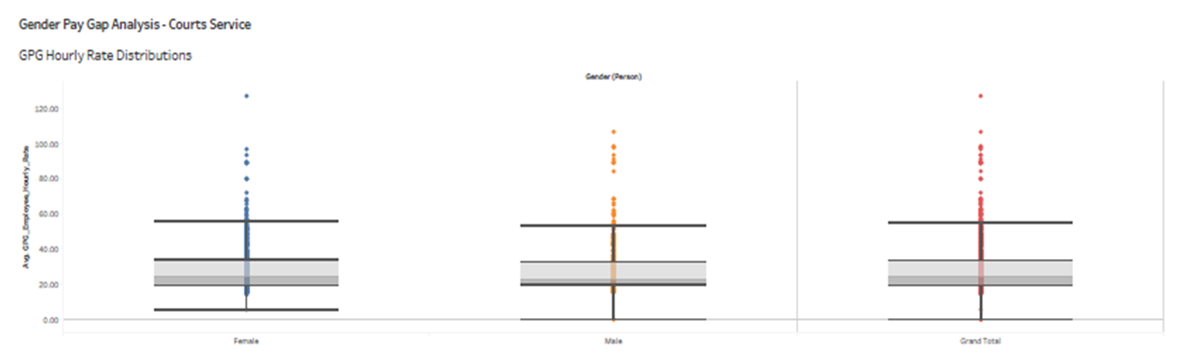
This chart is for indicative purposes. The left hand column in blue represents females and the middle column in orange represents males. The right hand column represents all staff.

Using Gender Pay Gap information.
The Courts Service established an Inclusion Group under the governance of our People & Organisation Strategy. All public bodies in Ireland have responsibility to promote equality, prevent discrimination and protect the human rights of employees, customers, service users and everyone affected by their policies and plans.
The Courts Service has developed a Public Sector Duty Action Plan to deliver on our obligations to be equitable and fair, attract and develop a diverse workforce.
The benefit of gender pay gap reporting is to provide data for us to evaluate and challenge ourselves around Equality, Diversity and Inclusion in our workplace and consider ways to enhance our support to all genders.

